Membranous organelles

Description: Explore the mitochondria, peroxisomes and endomembrane system.

## Learning objectives:

After completing this study unit, you will be able to:

1. Discuss the importance of membranes around cell organelles.
2. Describe the structure and function of mitochondria and peroxisomes.
3. Explain the structure and function of the endomembrane system including the endoplasmic reticulum, Golgi apparatus and lysosomes.

## Introduction:

The cell is the structural and functional unit of all living organisms. Each cell is bounded by a **cell membrane** (plasma membrane)and contains a **nucleus** and **cytoplasm,** with **organelles** suspended in a gel-like substance known as **cytosol**.

**Membranous** (membrane-bound) organelles include the nucleus, endoplasmic reticulum, Golgi apparatus, lysosomes, mitochondria and peroxisomes. The membrane keeps proteins and enzymes dedicated to a particular function within a specific compartment and ensures that toxic substances are isolated within the cell.

**Mitochondria** are the powerhouse of the cell. Their enzymes extract energy from food breakdown in the form of adenosine triphosphate (**ATP**) via a process known as **oxidative** **phosphorylation**.

**Peroxisomes** contain oxidases and catalases, responsible for detoxifying harmful substances and breaking down very long chain fatty acids.

The nuclear envelope, endoplasmic reticulum, Golgi apparatus and lysosomes form the **endomembrane** system. This system modifies, sorts and packages proteins and lipids into vesicles to be transported to their appropriate destinations within and outside the cell.

Watch the following video to learn more about how this team of organelles work together!

Embedded video: Cytoplasm and organelles (TBD)

## Explore concepts

## Membranous organelles

Membranous organelles include the nucleus, endoplasmic reticulum, Golgi apparatus, mitochondria, lysosomes and peroxisomes.

### 1st image: OV

OV:

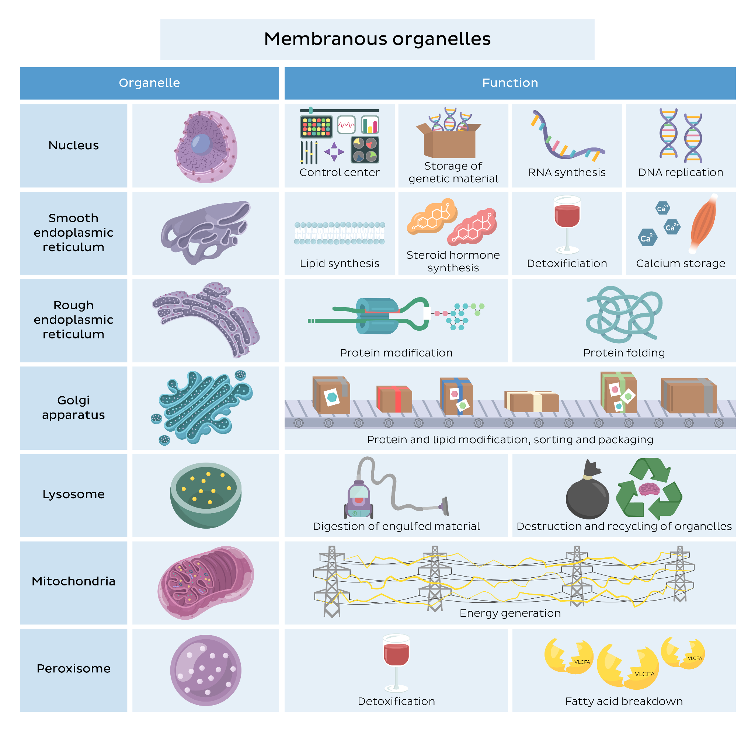

Caption:[Membranous organelles]Infographic summarizing the important functions of membranous organelles in the cell.

## Mitochondrion

Mitochondria, the powerhouse of the cell, have a structure designed to suit their functions.

OV:

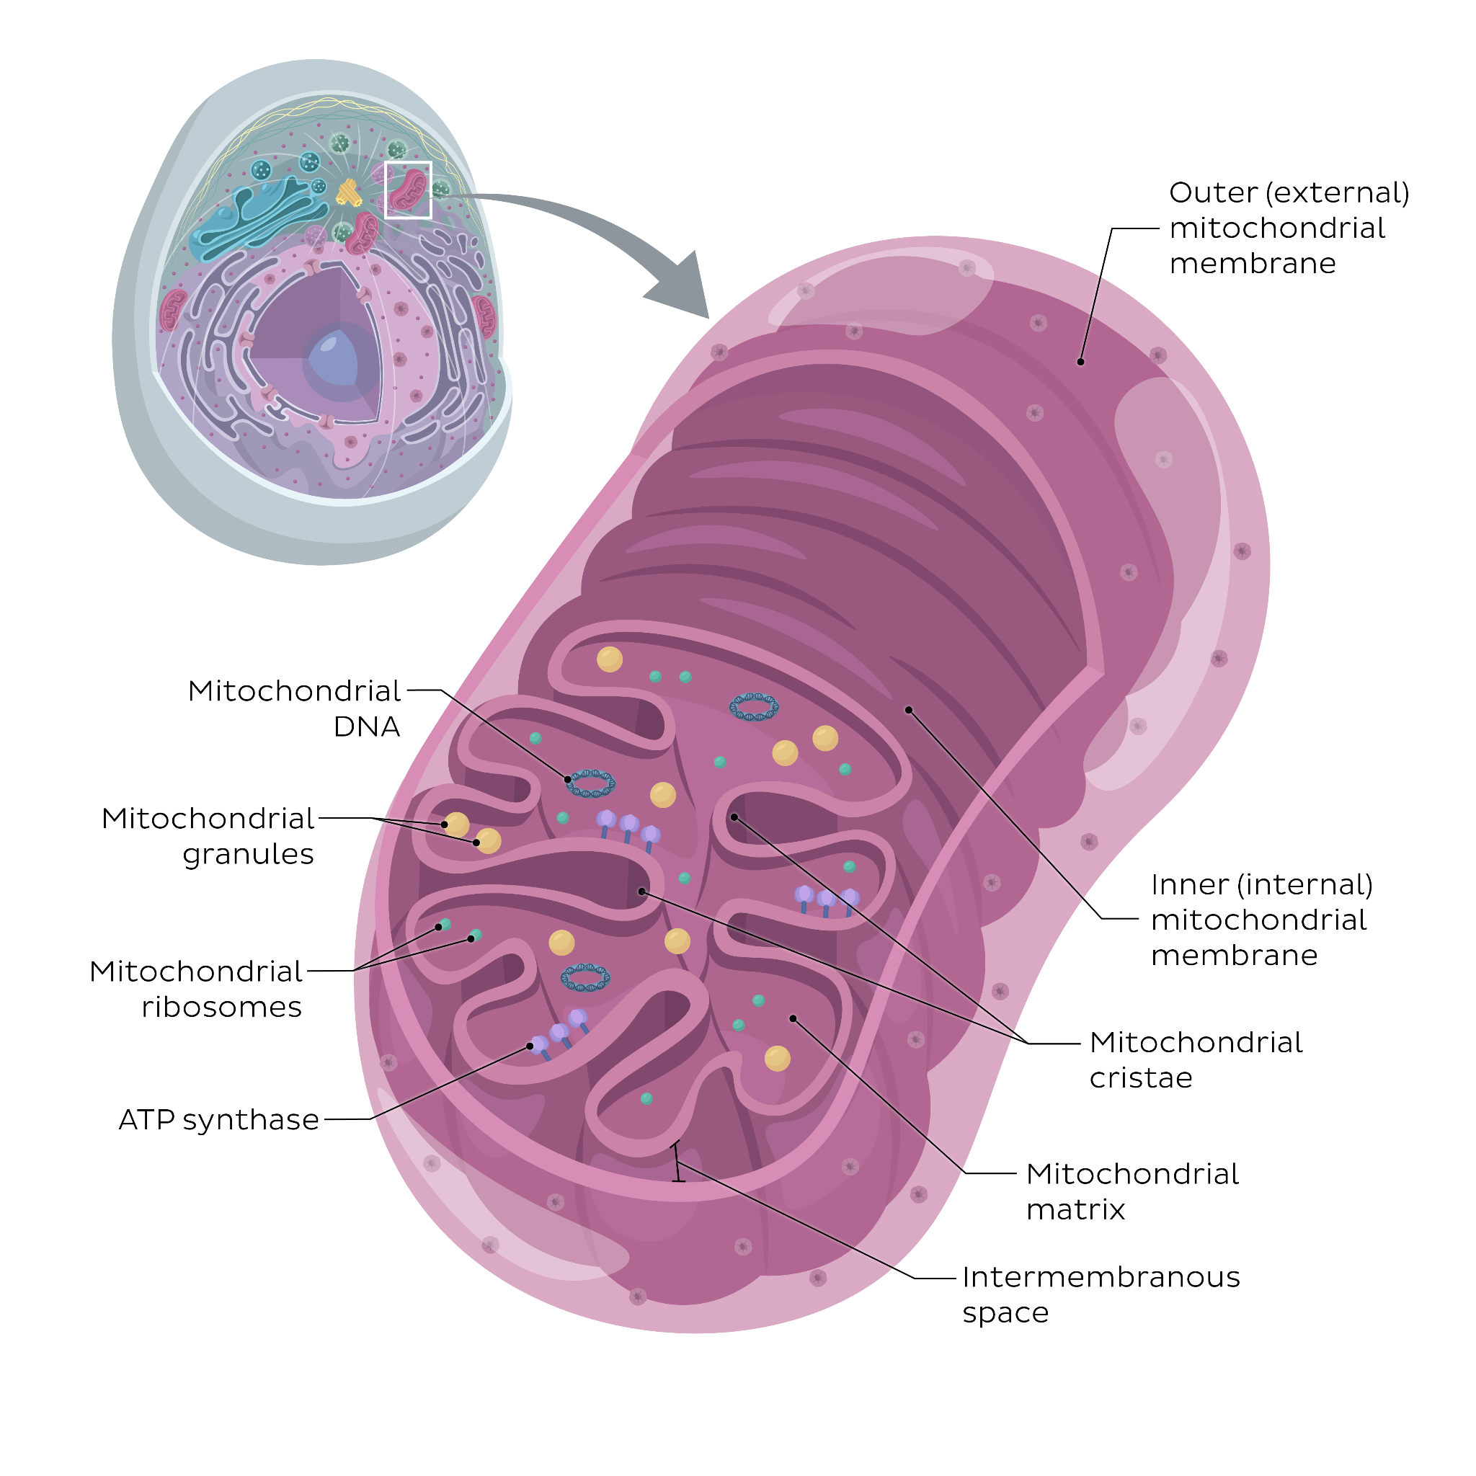

Caption:[Mitochondrion]The mitochondrion is a double-membraned organelle, with an **outer** and **inner** **membrane**. Between the two membranes is an **intermembranous** **space** and within the inner membrane is the **mitochondrial** **matrix**. The inner mitochondrial membrane contains enzymes needed for **oxidative** **phosphorylation** such as ATP synthase, crucial for the mitochondrion’s primary function, **energy** production.

Endomembrane system

The endomembrane system is a network of organelles including the nuclear envelope, endoplasmic reticulum, Golgi apparatus, lysosomes and vesicles.

OV:

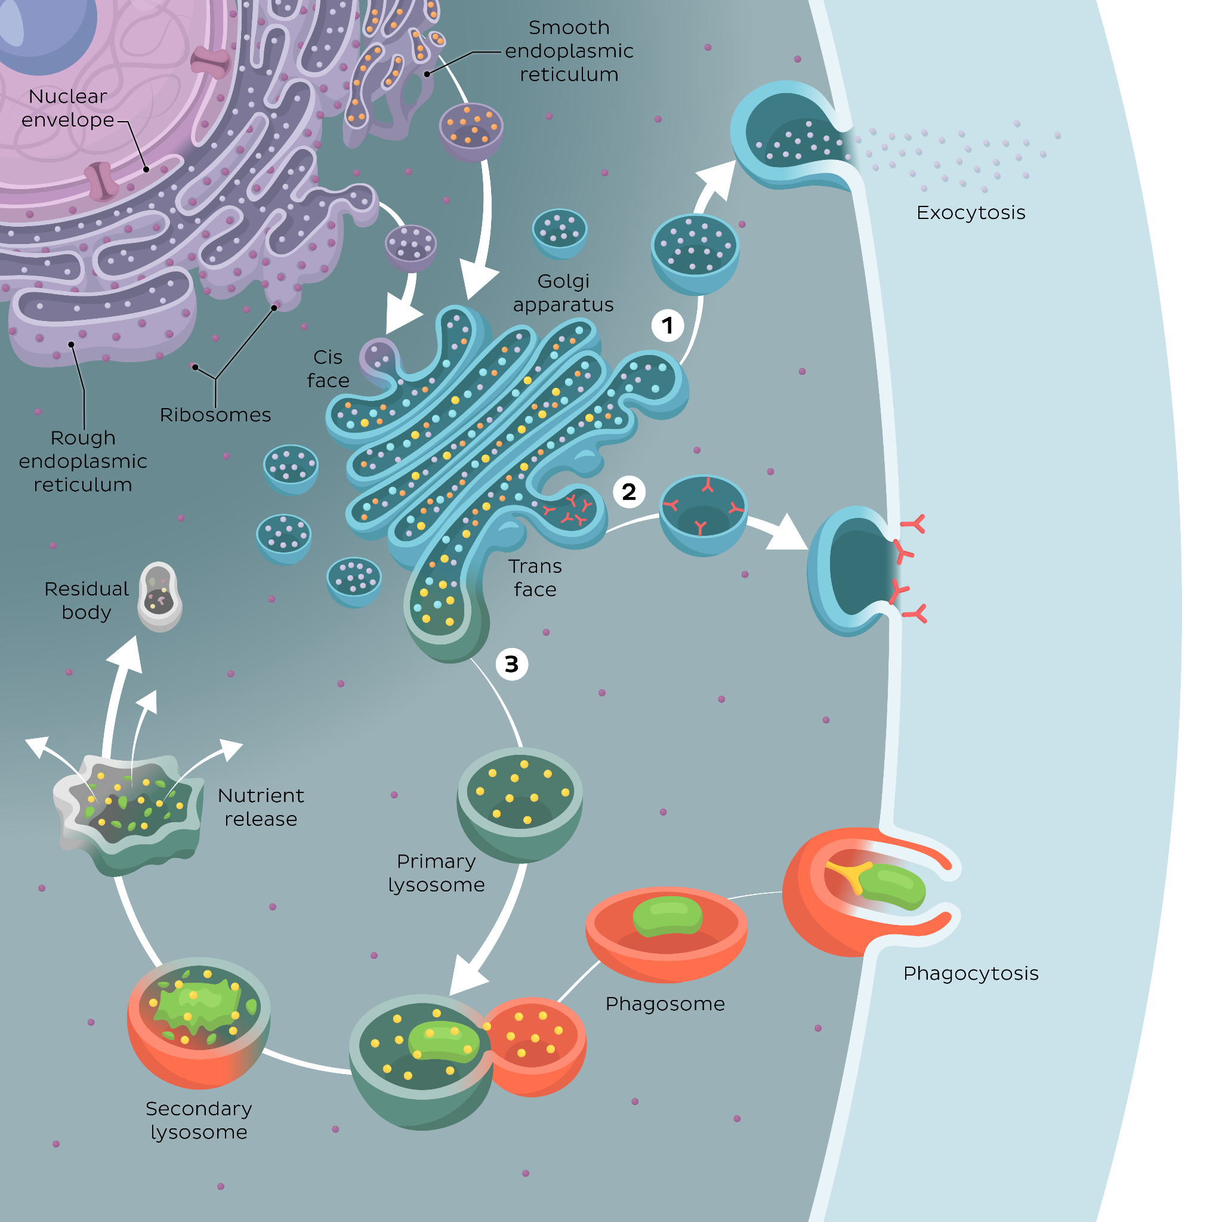

Caption:[Endomembrane system]The outer membrane of the **nuclear envelope** is continuous with the membrane of the rough endoplasmic reticulum. Proteins synthesized in bound ribosomes enter the lumen of the **rough** **endoplasmic** **reticulum** where they undergo folding and modification. Vesicles bud from the rough ER to form transport vesicles. Lipids synthesized in the **smooth** **endoplasmic** **reticulum** are also placed into **transport** **vesicles**. The transport vesicles fuse with the **cis** (**receiving**) face of the **Golgi** **apparatus**. In the cisternae of the Golgi apparatus, proteins and lipids undergo further modifications and towards the **trans** (**shipping**) face, they get sorted and packaged into vesicles with three common destinations: fusion and release of contentsinto the extracellular space by **exocytosis** (1), fusion and contribution to the **plasma** **membrane** (2) and formation of **lysosomes** (3).

## Lysosome

Lysosomes are the recycling crew of the cell.

4 OVs

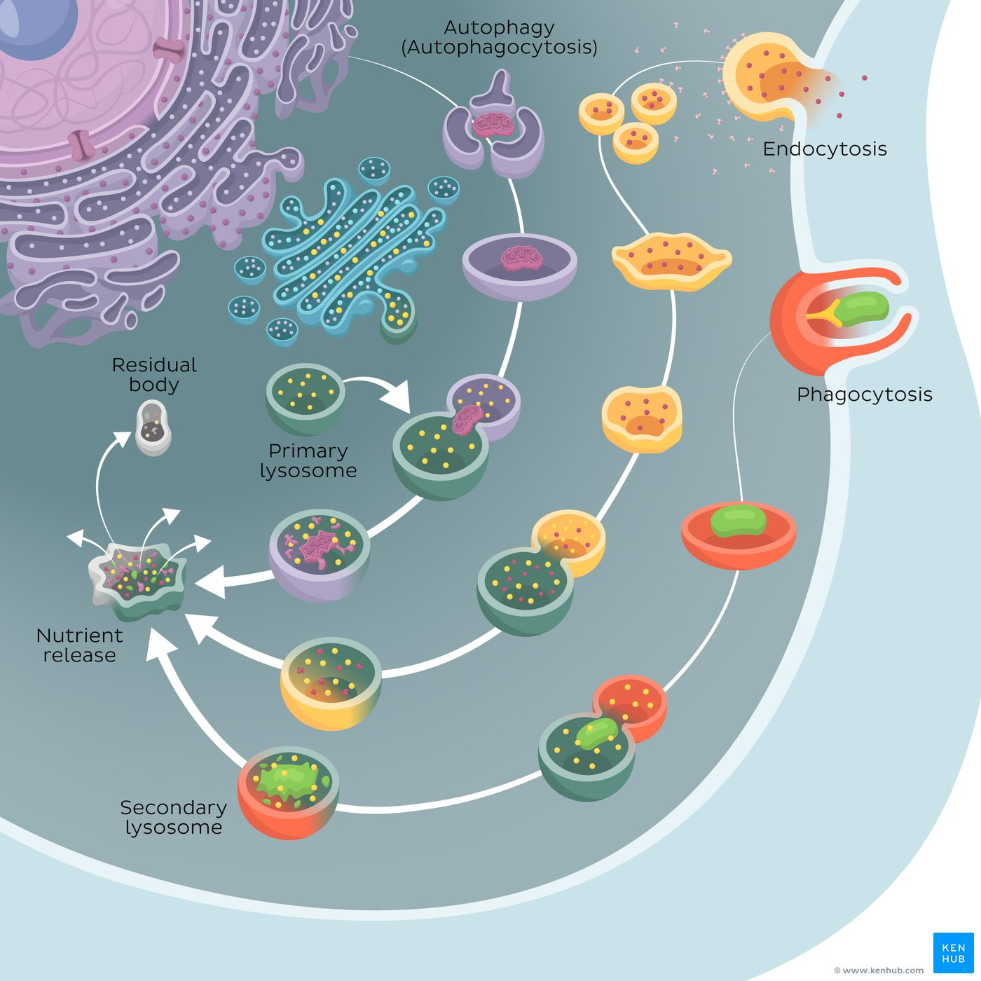

Caption:[Lysosome]**Primary** **lysosomes** contain **acid** **hydrolases** and originate from the Golgi apparatus. Material from the extracellular environment can be taken up by **endocytosis** and **phagocytosis**. The contents enter the cell in the form of vesicles, which fuse with the primary lysosome to form **secondary** **lysosomes**. The acid hydrolases break down the material, releasing nutrients into the cytosol while the remaining indigestible material forms a **residual** **body**. Lysosomes are also responsible for recycling **damaged** cell organelles by a process known as **autophagy**.

## 

## 

Caption:[Endolysosome]The illustration shows the role of the lysosome after **endocytosis**. The cell takes up material from the extracellular environment forming endocytic vesicles. These vesicles fuse with endosomes, and late endosomes fuse with **primary** **lysosomes** to form **endolysosomes** (**secondary** **lysosomes**). Here the material is digested by acid hydrolases releasing nutrients while the remaining indigestible material forms a residual body. Contents from the residual body can be expelled from the cell by exocytosis (not shown here).

## 

## 

Caption:[Phagolysosome] The illustration shows the role of the lysosome after **phagocytosis**. The cell forms pseudopods to take up material such as bacteria from the extracellular environment forming **phagosomes**. These vesicles fuse with **primary** **lysosomes** to form **phagolysosomes** (**secondary** lysosomes). Here the material is digested by acid hydrolases releasing nutrients while the remaining indigestible material forms a residual body. Contents from the residual body can be expelled from the cell by exocytosis (not shown here).

## 

Caption:[Autophagolysosome] The illustration shows the role of the lysosome in **autophagy**. The cell forms a membrane around damaged organelles creating a vesicle (**autophagosome**) which fuses with the **primary** **lysosome**. This forms an **autophagolysosome** (**secondary** lysosome). Here the material is digested by acid hydrolases releasing nutrients while the remaining indigestible material forms a residual body. Contents from the residual body can be expelled from the cell by exocytosis (not shown here).

## Take a quiz

Reinforce what you’ve learnt about the cytoplasm and its organelles with this quiz!

[Cytoplasm and organelles quiz](https://www.kenhub.com/admin/quizzes/cytoplasm-and-organelles)

## Summary

| **Key facts about the membranous organelles** |  |
| --- | --- |
| **Membranous (membrane-bound) organelles** | Nucleus  Endoplasmic reticulum  Golgi apparatus  Lysosome  Mitochondria  Peroxisome |
| **Mitochondrion** | Bean-shaped organelle with two membranes: outer and inner membrane  Extracts energy from food breakdown products in the form of ATP |
| **Peroxisomes** | Spherical organelle with a membrane  Detoxifies toxic substances and breaks down very long chain fatty acids |
| **Endomembrane system** | Includes nuclear envelope, endoplasmic reticulum, Golgi apparatus, lysosomes  Modifies, sorts and packages proteins and lipids |
| **Endoplasmic reticulum** | Network of interconnected membrane-bound tubules and sacs.  **Rough endoplasmic reticulum**: Has ribosomes, folds and modifies proteins  **Smooth endoplasmic reticulum**: No ribosomes, synthesizes lipids, detoxifies toxic substances (ethanol), stores and controls the release of calcium |
| **Golgi apparatus** | Sacs and vesicles arranged in stacks with a cis (receiving) face and trans (shipping) face  Modifies, sorts and packages proteins and lipids |
| **Lysosome** | Spherical membranous organelle that contains acid hydrolases  Digests material that enters the cell and recycles organelles  **Endolysosome**: formed after endocytosis  **Phagolysosome**: formed after phagocytosis  **Autophagolysosome**: formed during autophagy |

## Related anatomy SU

<https://www.kenhub.com/en/study/histology-eukaryotic-cell>

<https://www.kenhub.com/en/study/cells-and-tissues-of-human-body>

## Related content

<https://www.kenhub.com/en/library/anatomy/cellular-organelles>

<https://www.kenhub.com/en/library/anatomy/cytoplasm>